# Sample social media post

The Get Active Kids Voucher Program is open! Get in quick as applications for a voucher will close when the allocation has been exhausted.

Victorian families with a Health Care Card or Pensioner Concession Card can apply for up to $200 to support their child’s sport and active recreation activities. Apply now at [www.getactive.vic.gov.au/vouchers](http://www.getactive.vic.gov.au/vouchers)

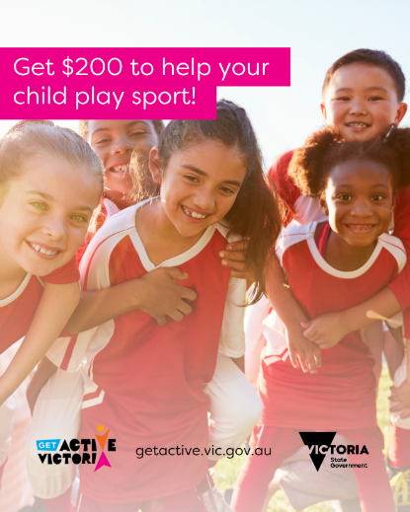

# Sample text for newsletters and websites

## For activity providers to share with their members

# The Get Active Kids Voucher Program is now open!

We are pleased to let you know that we are a Get Active Kids Voucher Program Activity Provider and Round 7 is open! Get in quick as applications for a voucher will close when the allocation has been exhausted.

If your family or child has a Health Care Card or Pensioner Concession Card, you may be eligible for up to $200 to put towards the cost of your child’s registration and membership fees at <insert club name>.

Important Dates:

**Round 7 open to apply for a voucher or reimbursement:** 10:00 amTuesday, 10 October 2023until allocation exhausted

**Reimbursement dates:** from8 May 2023 until allocation is exhausted

**Vouchers expiry date:** Tuesday, 30 April 2024.

Apply now at [www.getactive.vic.gov.au/vouchers](http://www.getactive.vic.gov.au/vouchers) to have your voucher emailed to you. Let us know your voucher code when you pay your fees and we will take up to $200 off the registration and membership fee (as well as any included uniforms and/or equipment).

Tip: Be sure to select us as your Activity Provider. We are listed as <Insert club name> and our Get Active Kids Voucher Program number is <insert number>.

If you have already paid for your child’s activity, you can apply for a reimbursement. You can only apply for either one voucher or a reimbursement for each child in Round 7.

Special consideration applies for children residing in care services as well as temporary or provisional visa holders, undocumented migrants or international students.

To find out if you are eligible, how to apply, what costs are covered and more, visit [www.getactive.vic.gov.au/vouchers](http://www.getactive.vic.gov.au/vouchers)

## For Schools, LGAs, support services etc.

# The Get Active Kids Voucher Program is now open!

The Get Active Kids Voucher Program is now open! Get in quick as applications for a voucher will close when the allocation has been exhausted.

If your family or child has a Health Care Card or Pensioner Concession Card, you may be eligible for up to $200 to put towards the cost of your child’s participation in sport and active recreation activities.

Important Dates:

**Round 7 open to apply for a voucher or reimbursement:** 10:00 amTuesday, 10 October 2023until allocation exhausted

**Reimbursement dates:** from8 May 2023 until allocation is exhausted

**Vouchers expiry date:** Tuesday, 30 April 2024.

The *Get Active Kids Voucher Program* helps eligible families get their kids involved in organised sport and active recreation activities by providing financial support for the cost of membership and registration fees. Eligible children may be able to receive up to $200 each.

Special consideration also applies for children residing in care services, as well as temporary or provisional visa holders, undocumented migrants, or international students.

To find out if you are eligible, how to apply, what costs are covered and more, visit [www.getactive.vic.gov.au/vouchers](http://www.getactive.vic.gov.au/vouchers)