BRIEF
Vouchers opening Sept 2022

Project description
Amend Vouchers pages on the Get Active Victoria website in preparation for round 5 opening.

 | Reimbursement | Vouchers - Applications | Vouchers - Activity Providers
Opening Date | 10 am, Tues 20th Sept | 10 am, Tues 20th Sept | Always open

Deliverables
Tuesday 20 September
APPLY FOR VOUCHERS PAGE
Time | Section/Update | Current | Copy
10am | Intro page  Copy Update | 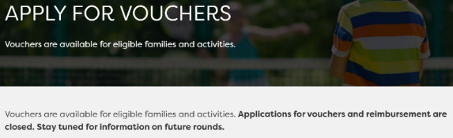 | APPLY FOR THE PROGRAM  Vouchers and reimbursements are available for eligible families and activities.  Applications are now open.
10 am | Intro page  Insert buttons | 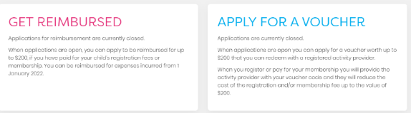 | Insert ‘Get Reimbursed’ and ‘Apply for a voucher’ buttons under text
10am | Intro page  Get reimbursed  Copy update | 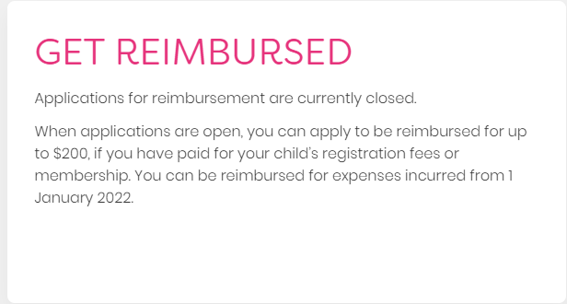 | If you have paid for your child’s registration or membership fees you can apply to be reimbursed for up to $200. You can be reimbursed for expenses incurred from 1 January 2022.  Applications for reimbursement are now open.
10am | Intro page  - Apply for a voucher  Copy update | 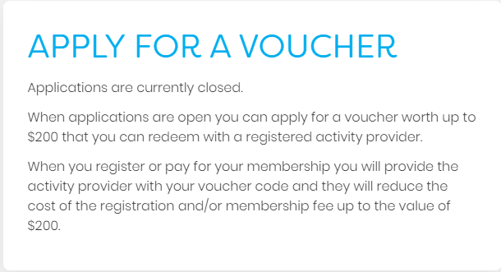 | You can apply for a voucher worth up to $200 that you can redeem with a registered activity provider.  When you register or pay for your child’s membership and any related uniform or equipment, you will provide the activity provider with your voucher code and they will reduce the fees up to the value of $200.  Applications for vouchers are now open.
10am | Get Reimbursed box- How to be reimbursed  Copy Update | 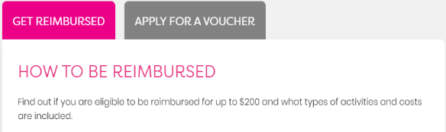 | HOW TO BE REIMBURSED  Find out if you are eligible to be reimbursed for up to $200 and what types of activities and costs are included. Read the Program Guidelines [insert hyperlink to come], including Terms and Conditions, for detailed information.
10am | Get Reimbursed box- When can you apply?  Copy Update | 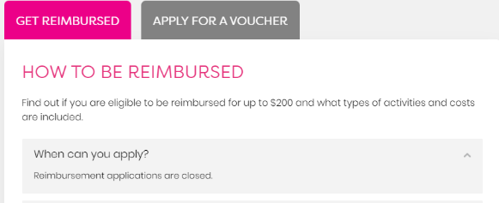 | When can you apply?  Reimbursement applications are open.  Eligible expenses must have been incurred from 1 January 2022.
Early | Get Reimbursed box  Who is eligible?  Copy Update | 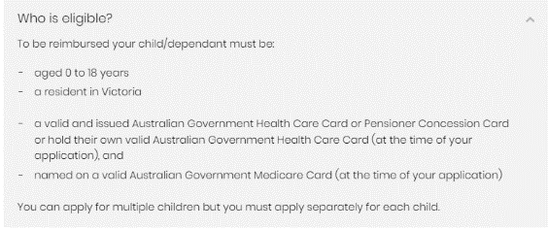 | To be reimbursed your child/dependant must be:  - aged 0 to 18 years  - a resident in Victoria  - named on an issued and valid Australian Government Health Care Card or Pensioner Concession Card, or hold their own valid Australian Government Health Care Card (at the time of your application), and  - named on an issued and valid Australian Government Medicare Card (at the time of your application).  You can apply for multiple children but you must apply separately for each child.
Early | Get Reimbursed box- Special Consideration  Copy Update | 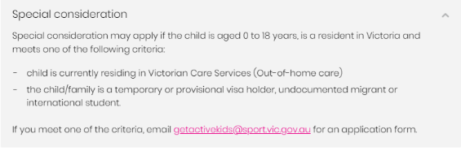 | Special consideration may apply if the child is aged 0 to 18 years, is a resident in Victoria and meets one of the following criteria:  - child is currently residing in Victorian Care Services (out-of-home care), or  - the child/family is a temporary or provisional visa holder, undocumented migrant or international student.  See ‘What is special consideration? ‘ in FAQs for more information.  If you meet one of the criteria, email getactivekids@sport.vic.gov.au for an application form.
10am | Get Reimbursed box- What costs are covered?  Link Update | 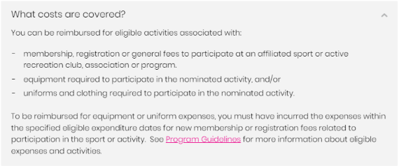 | Change Program Guidelines link to R5 guidelines [insert link]
10am | Get Reimbursed box- Program Guidelines  Link Update | 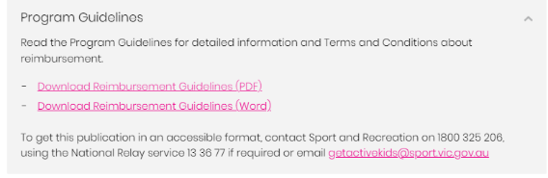 | Update links to R5 guidelines  [insert PDF link]  [insert Word link]
10am | Apply for a voucher box- Apply for a voucher  Copy Update |  | APPLY FOR A VOUCHER  Find out if you are eligible and where you can use your voucher. Read the Program Guidelines [insert link], including Terms and Conditions, for detailed information.
Early | Apply for a voucher box- Voucher amounts  Copy Update | 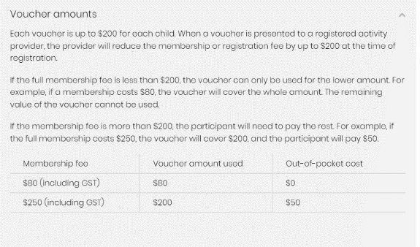 | Each voucher is up to $200 for an eligible child. When a voucher is presented to a registered activity provider, the provider will reduce the membership or registration fee (and any related uniform or equipment costs included with registration) by up to $200 at the time of registration.  If the total amount is less than $200, the voucher can only be used for that amount. For example, if the total amount is $80 the voucher will cover the whole amount. The remaining value of the voucher cannot be used with another activity provider.  If the total amount is more than $200, the participant will need to pay the rest. For example, if the total amount is $250, the voucher will cover $200 and the participant will pay $50.
10am | Apply for a voucher box- When can I apply for a voucher?  Copy Update |  | When can I apply for a voucher?  You can apply from 20 September 2022 to 30 November 2022.
Early | Apply for a voucher box- How do I use my voucher?  Copy Update | 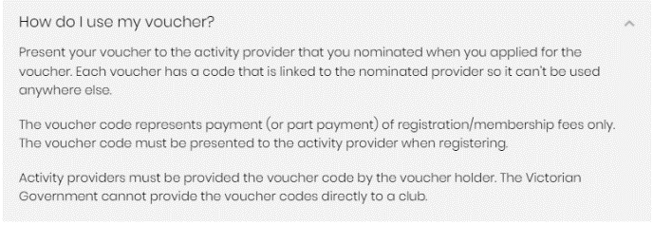 | Present your voucher to the activity provider that you nominated when you applied for the voucher. Each voucher has a code that is linked to the nominated provider so it cannot be used anywhere else.  The voucher code represents payment (or part payment) of registration/membership fees. The voucher code must be presented to the activity provider when registering.  The Victorian Government cannot provide the voucher codes directly to an activity provider. It must be presented by the voucher holder.
10am | Apply for a voucher- Program Guidelines  Link Update | 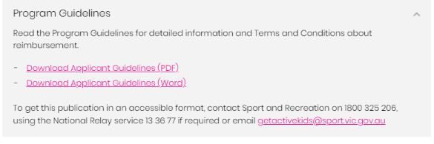 | Update links to R5 guidelines  [Insert PDF link]  [Insert Word link]

INFO FOR PROVIDERS PAGE
Time | Section | Current | Update
10am | Intro page  Copy Update | 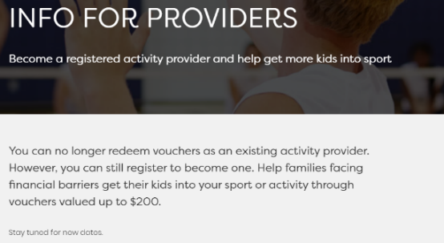 | Become a registered activity provider and help get more kids into sport. Register to become an activity provider.  Help families facing financial barriers get their kids into your sport or activity through vouchers valued up to $200.
10am | Intro page  Redeem now |  | Reactivate Redeem now button
Early | Eligibility  Copy Update | 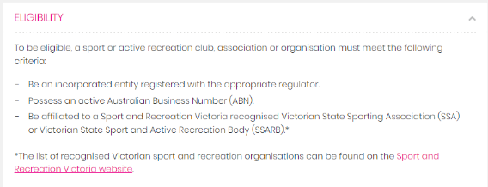 | To be eligible, a sport or active recreation club, association or organisation must meet the following criteria:  Be an incorporated entity registered with the appropriate regulator.  Possess an active Australian Business Number (ABN).  Be affiliated to a Sport and Recreation Victoria recognised Victorian State Sporting Association (SSA) or Victorian State Sport and Active Recreation Body (SSARB)  *The list of recognised Victorian sport and recreation organisations can be found on the Sport and Recreation Victoria website.  Local Government Authorities, facilities managed by the State Sport Centres Trust and facilities managed by Alpine Resorts Victoria are also eligible to register to participate in the Program.
10am | Program Guidelines  Link Update | 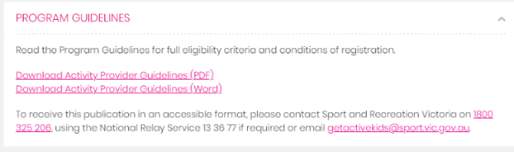 | Insert R5 guidelines links [Insert link]
Early | How to Register | 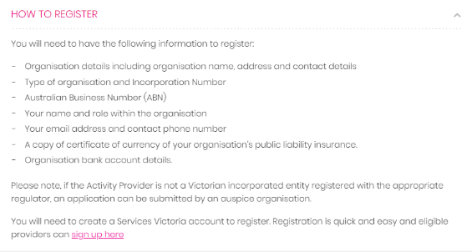 | You will need to have the following information to register:  - Organisation details including organisation name, address and contact details  - Type of organisation and Incorporation Number  - Australian Business Number (ABN)  - Your name and role within the organisation  - Your email address and contact phone number  - A copy of certificate of currency of your organisation’s public liability insurance.  - Organisation bank account details.  Please note, if you are not a Victorian incorporated entity registered with the appropriate regulator, an application can be submitted by an auspice organisation.  You will need to create a Service Victoria account to register. Registration is quick and easy and you can sign up here
10am | Redeem Vouchers | 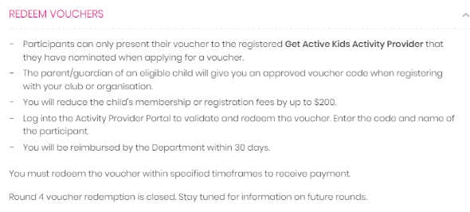 | Vouchers issued in Round 5 of the Program must be redeemed between Tuesday 20 September 2022 and Tuesday 10 January 2023.

FAQS
Time | Section | Current | Update
10am | FAQs for Providers  Copy Update  Update Program Guidelines link | 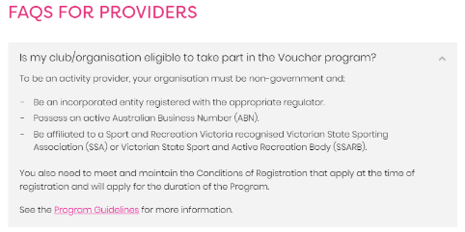 | Is my club/organisation eligible to take part in the voucher program?  To be eligible, your sport or active recreation club, association or organisation must:  - Be an incorporated entity registered with the appropriate regulator.  - Possess an active Australian Business Number (ABN).  - Be affiliated to a Sport and Recreation Victoria recognised Victorian State Sporting Association (SSA) or Victorian State Sport and Active Recreation Body (SSARB).  Local Government Authorities, facilities managed by the State Sport Centres Trust and facilities managed by Alpine Resorts Victoria are also eligible to register to participate in the Program.  You also need to meet and maintain the Conditions of Registration that apply at the time of registration and will apply for the duration of the Program.  See the Program Guidelines [insert new link] for more information.
10am | FAQs for Providers  Copy Update  Update Program Guidelines link | 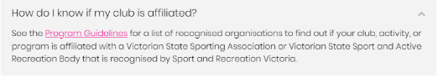 | How do I know if my club is affiliated?  The list of recognised Victorian sport and recreation organisations can be found on the Sport and Recreation Victoria website and also in the Program Guidelines. [insert new link]
Early | FAQs for Providers- Registration  Copy Update | 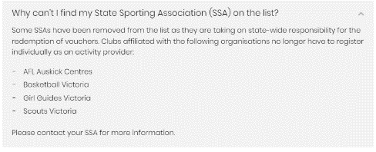 | Some SSAs have been removed from the list as they are taking on state-wide responsibility for the redemption of vouchers. Clubs affiliated with the following organisations do not need to register individually as an activity provider:  - AFL Auskick centres  - Athletics Victoria  - Auscycling  - Basketball Victoria  - Cricket Victoria  - Girl Guides Victoria  - Golf Australia  - Motorcycling Victoria  - Scouts Victoria  Please contact your SSA for more information.
Early | FAQs for Providers- Registration  Copy Update | 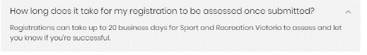 | How long does it take for my registration to be assessed once submitted?  Registrations can take up to 15 business days for Sport and Recreation Victoria to assess and let you know if you’re successful.
Early | FAQs for Providers- Registration  Copy Update | 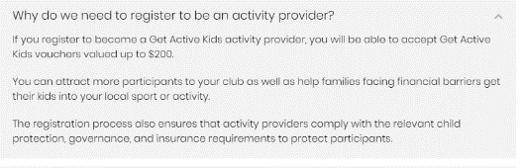 | Why do we need to register to be an activity provider?  A registered Get Active Kids activity provider is able to accept Get Active Kids vouchers valued up to $200.
Early | FAQs for Providers- Accepting and redeeming vouchers  Copy Update | 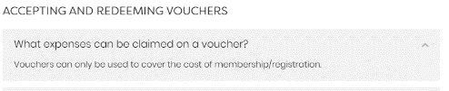 | What expenses can be claimed on a voucher?  Vouchers can only be used to cover the cost of membership and registration.  Uniform and equipment items that are incorporated within the membership and registration fees can be claimed (for example, safety equipment, mouthguards).
Early | FAQs for Providers- Accepting and redeeming vouchers  Copy Update | 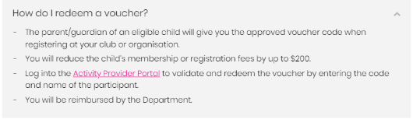 | How do I redeem a voucher?  - The parent/guardian of an eligible child will give you the approved voucher code when registering at your club or organisation.  - You will reduce the child’s membership or registration fees by up to $200.  - Log into the Activity Provider Portal to validate and redeem the voucher by entering the code and name of the participant  - You will be reimbursed by the Department.  - You must redeem the voucher within specified timeframes to receive payment.
Early | FAQs for Providers- Accepting and redeeming vouchers  Copy Update | 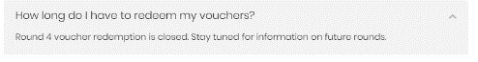 | Reimbursement will occur within 30 days of vouchers being approved for payment.
Early | FAQs for Applicants  Copy Update | 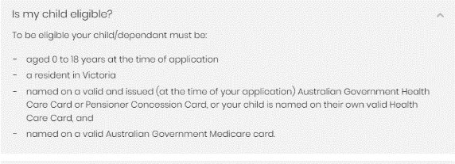 | Is my child/dependant eligible?  To be eligible your child/dependant must be:  - Aged 0 to 18 years at the time of application.  - A resident in Victoria.  - Named on a valid and issued (at the time of your application) Australian Government Health Care Card or Pensioner Concession Card, or your child is named on their own valid Health Care Card.  - Named on a valid Australian Government Medicare card.  Special consideration may apply if the child is currently residing in Victorian Care Services or the family is a temporary or provisional visa holder, undocumented migrant or international student.
Early | FAQs for Applicants- Apply for a voucher  Link Update | 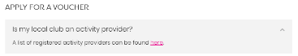 | Update link [within email].
10am | FAQs for Applicants- Apply for a voucher  Copy Update | 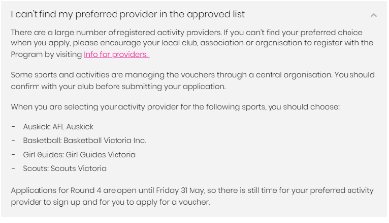 | I can’t find my preferred provider in the approved list  There are a large number of registered activity providers. If you can’t find your preferred choice when you apply, please encourage your local club, association or organisation to register with the Program by visiting Info for providers.  Some sports and activities are managing the vouchers through a central organisation. You should confirm with your club before submitting your application.  When you are selecting your activity provider for the following sports, you should choose:  - Auskick: AFL Auskick  - Athletics: Athletics Victoria  - Basketball: Basketball Victoria Inc.  - Cricket: Cricket Victoria  - Cycling: Auscycling  - Girl Guides: Girl Guides Victoria  - Golf: Golf Australia  - Motorcycling: Motorcycling Victoria  - Scouts: Scouts Victoria  Applications for Round 5 are open until Wednesday 30 November, so there is still time for your preferred activity provider to sign up, and for you to apply for a voucher.
Early | FAQs for Applicants- Apply for a voucher  Removal | 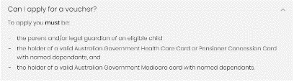 | Remove as at the top of FAQS for Applicants
Early | FAQs for Applicants- Apply for a voucher  Removal | 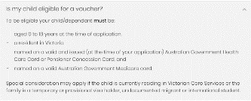 | Remove as at the top of FAQS for Applicants
Early | FAQs for Applicants- Apply for a voucher  Copy Update | 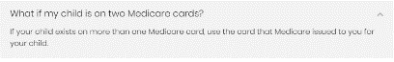 | What if my child/dependant is on two Medicare cards?  If your child/dependant exists on more than one Medicare card, use the card that Medicare issued to you for your child/dependant.
Early | FAQs for Applicants- Apply for a voucher  Copy Update | 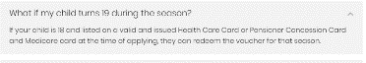 | What if my child/dependant turns 19 during the season?  If your child/dependant is 18 and listed on a valid and issued Health Care Card or Pensioner Concession Card and Medicare card at the time of applying, they can redeem the voucher for that season.
10am | FAQs for Applicants- Apply for a voucher  Copy Update | 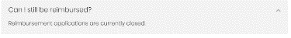 | Reimbursement applications are open from 20 September 2022 and close on 30 November 2022.  Eligible applicants can ONLY apply for either one voucher OR reimbursement for each eligible child per round.
Early | FAQs for Applicants- Apply for a voucher  Copy Update- Merged the two questions to one | 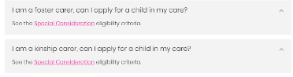 | I am a foster carer or a kinship carer, can I apply for a child/dependant in my care?  See the Special Consideration eligibility criteria.
Early | FAQs for Applicants- Apply for a voucher  Copy Update | 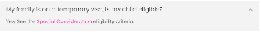 | My family is on a temporary visa, is my child/dependant eligible?  Yes, See the Special Consideration eligibility criteria.
Early | FAQs for Applicants- Expenses covered  Copy Update | 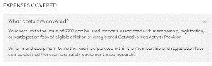 | What costs are covered?  Eligible children may receive up to $200 to cover the costs of membership and registration fees.  Uniform and equipment items that are incorporated within the membership and registration fees can be claimed (for example, safety equipment, mouthguards).
Early | FAQs for Applicants- Expenses covered  Remove question | 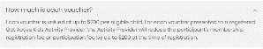 | Remove question
Early | FAQs for Applicants- Expenses covered  Copy Update | 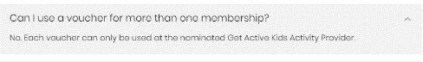 | Can I use a voucher for more than one membership?  No.  A voucher can only be used at the nominated Get Active Kids activity provider.  Eligible applicants can ONLY apply for either one voucher OR reimbursement for each eligible child per round.
10am | FAQs for Applicants- How to Apply  Copy Update |  | Voucher applications are open from 20 September 2022 until 30 November 2022.
Early | FAQs for Applicants- How to Apply  Copy Update |  | Each eligible child can apply for one voucher.  Eligible applicants can ONLY apply for either one voucher OR reimbursement for each eligible child per round.
Early | FAQs for Applicants- How to Apply  Copy Update | 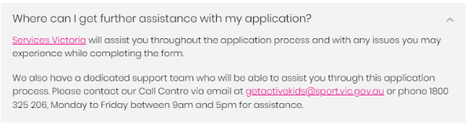 | Service Victoria will assist you throughout the application process and with any issues you may experience while completing the form.  We also have a dedicated support team who will be able to assist you through this application process.  Please contact our Call Centre via email at getactivekids@sport.vic.gov.au or phone 1800 325 206, Monday to Friday between 9am and 5.30pm for assistance.
10am | FAQs for Applicants- About your application  Copy Update | 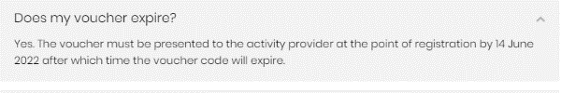 | Yes. The voucher must be presented to the activity provider at the point of registration by 10 January 2023 after which time the voucher code will expire.
Early | FAQs for Applicants- About your application  Copy Update | 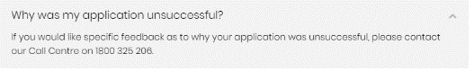 | If you would like specific feedback as to why your application was unsuccessful, please email getactivekids@sport.vic.gov.au.
Early | FAQs for Applicants- Using your voucher  Copy Update | 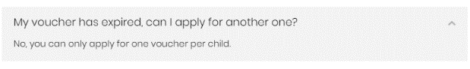 | My voucher has expired, can I apply for another one?  No, you can only apply for one voucher per child per round.
10am | FAQs for Applicants- Reimburse-ment  Copy Update  Link Update | 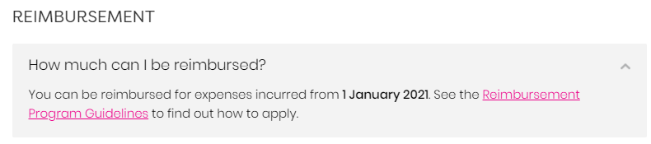 | You can be reimbursed for expenses incurred from 1 January 2022. See the Reimbursement Program Guidelines [insert new link] to find out how to apply.
10am | FAQs for Applicants- Reimbursement  Copy Update |  | Reimbursement applications are open from 20 September 2022 and close on 30 November 2022.
Early | FAQs for Applicants- Reimburse-ment  Removal | 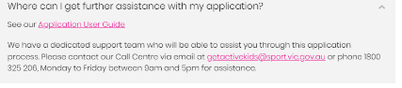 | Remove question
Early | FAQs Page- Contact  Copy Update |  | If you have questions or require further support, contact the Get Active Kids Voucher Program Team.  Phone: 1800 325 206 for the cost of a local call (except from mobile phones)  Email: getactivekids@sport.vic.gov.au  Monday – Friday, 9am – 5.30pm (closed weekends and Public Holidays)

PROMO PACK
Time | Section | Current | Update
10am | Homepage | N/A | Make promo pack summary on homepage visible
10am | Promo Pack page | N/A | Make Promo pack webpage visible

Key dates
Changes to be made Tuesday 20 September at 10am.
A reminder that this cannot be done a minute before or after 10:00am as this can cause issues for the vouchers team.

Any questions?
- Contact: Lucy Bishop, Sport and Recreation Victoria
- Email: lucy.bishop@sport.vic.gov.au
- Phone: 0458 549 030

